 ACN 116231595

**2014 Annual Report**

**Australian Health Promotion Association (SA Branch)**

**President’s Report – Janette Young**

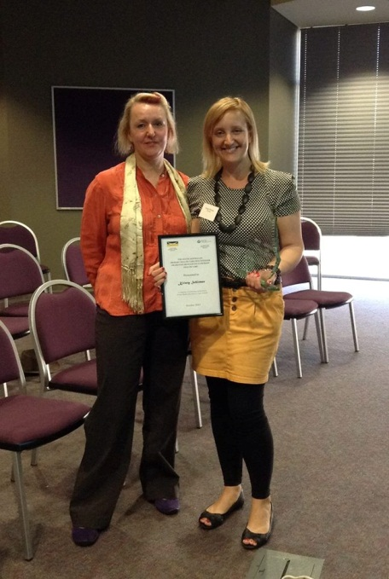

Janette Young (President AHPA SA) with Kristie Schirmer (Award recipient).

In 2014 your AHPA SA Committee worked on furthering the aims and ideas developed in 2013 leading to some new initiatives balanced by reduced engagement in what had become regular activities.

*Practitioner Award* - One of the highlights of 2014 was the awarding of the 2014 SA Primary Health Care Practitioner Award to Kristy Schirmer. The winner of this award is identified as a person who demonstrates an ongoing commitment to the principles of primary health care; excellence in their own practice; contributes to the promotion of primary health care at the broader organisational level thereby contributing to excellence in service provision to consumers; is available as a resource person and/or mentor; advocates on behalf of primary health care.

Kristy fulfills all these criteria admirably and her innovative approach to establishing a small business in a field where private practice is not common is an example of these qualities in operation: see zockmelon.com.au

*New Directions.* The Committee recognised the need to continue concentrating on health promoting activities outside the health sector. This led to the following key actions in 2014:

* The highly successful (in terms of engagement and finances) Mindfulness Symposium initiated and lead by Susan Cameron (Vice President) (see report)
* Initiation of SA Branch Facebook public and members pages.

# Continuing to work with ANZALS (Australian New Zealand Association for Leisure Studies) on a Health Promotion stream at their bi-annual conference, to be held in Adelaide December 10-12, 2015. The conference theme is “Leisure as a Human Right” (See Appendix 1).

* Mapping potential partners and strategies to facilitate “Getting Health Promotion back on the Public Agenda in SA” (see report).

To support these key action areas the Committee decided not to undertake the SA mentoring program in 2014 (see report) and reduced engagement with the State population health conference. We have been mindful of the impact of these changes on our relationship with PHAA SA. AHPA SA has had a very close relationship with the PHAA (Public Health Association of Australia) SA Branch for at least 10 years and look forward to continuing this relationship across new areas in 2015.

*National: Branch relationships* - The 2014 National AHPA conference was held in Alice Springs. The SA committee was able to identify two worthy recipients of one branch and one national conference scholarship. The recipients were Sara Dixon (who worked on setting up the conference social media platform <https://twitter.com/EquityCentre>) and Aimee Brownbill. Together with myself, Annabel Axford and Michelle Herriot we facilitated a conference workshop entitled “W(h)ither Health Promotion” exploring the opportunities, threats and creative options for Health Promotion/AHPA at this time.

A national initiative this year has been to establish Branch President teleconferences. There is discussion as to a national mentoring and ongoing National Conference committee. I have suggested that National investigate direct debit options re membership fees and this is being investigated. As President I write regular brief summaries of Branch activities for the National Bulletin.

SA was approached to consider hosting the 2016 national conference. The Committee decided to focus on local branch initiatives including the December 2015 ANZALS Conference.

*UniSA Student support team -* We again benefitted from the support of two UniSA Bachelor of Health Sciences industry practicum students – Nabila Al Kilabi (until mid 2014) and Diana Donga (Jan 2014 to Jan 2015). The students have undertaken the Executive Officer role to the committee. Many thanks to Nabila and Diana.

*SACOSS (South Australian Council of Social Services)* – As a member of SACOSS we have been able to be part of SACOSS’s active responding to various health impacting issues in the state. This included a late end of year response to the Transforming Health Review (Appendix 2). It has again been a privilege to work with Ross Womersley (Executive Director) and Kate Kameniar (Healthy Workers Adviser).

As President I receive strong support from my direct managers at UniSA (Professor Roger Eston and A/Professor Kerry Thoirs) who (again) approved the cost of my attendance at the AHPA National Conference. Thanks are also due to Kristy Schirmer from Zockmelon for donating time to work with the whole committee and even more time with the social media sub-committee.

We have had a strong and energetic committee this year. Many thanks Stefania Verlado (Treasurer), Alex Jackson (Correspondence Secretary), Lisa Lawton (Minutes secretary March to November), Annabel Axford (Student Project team consultant), Liana Bellifemini, Aimee Brownbill, Adam Delaine and Kristy Stengert. Special thanks to Susan Cameron (Vice President and start up Treasurer in 2014), who also spearheaded the Mindfulness Symposium and is stepping down from the committee. It has been a delight to work with you all. I believe we achieved a great deal this year as part of the ongoing project of maintaining a presence and facilitating a community of Health Promoters in SA.



**Dr Janette Young**

President, AHPA (SA)

**Treasurer’s Report**

I am pleased to report that 2014 has been an extremely successful financial year for AHPA SA. Our end of year balance of **$18,412.62** is extremely promising and provides scope for future branch projects/initiatives in 2015 which is exciting.

Our first source of significant income came in the form of national capitation, whereby we received $1615.05 in funds. However, extremely noteworthy was our Mindfulness Symposium held in September 2014 which generated significant revenue for our state branch. The event was extremely successful and our total profit was $10,588.84 ($12598.84 less a GST payment of $2010 which is still owing).

Please refer to the financial report below for information on monthly income and expenditure.

**Opening balance 1st January 2014 $6,402.10**

**Closing balance as at 31st December 2014 $18,412.62**

|  |  |
| --- | --- |
| **Income for the year ended 31st December 2014** | |
| **Date** | **Total** |
| January | nil |
| February | nil |
| March | $1,760.77 |
| April | nil |
| May | nil |
| June | nil |
| July | $600.00 |
| August | $2,807.46 |
| September | $16,110.05 |
| October | $1,000.00 |
| November | $70.00 |
| December | $16.50 |
|  | **$22,364.78** |
|  | |
| **Expenses for the year ended 31st December 2014** | |
| **Date** | **Total** |
| January | nil |
| February | $608.54 |
| March | nil |
| April | $178.99 |
| May | $36.96 |
| June | $401.91 |
| July | $77.28 |
| August | $871.02 |
| September | $3,889.21 |
| October | $4,045.84 |
| November | $119.93 |
| December | $124.58 |
|  | **$10354.26** |

I would like to take this opportunity to acknowledge Susan Cameron who assisted as I started out in the treasurer’s role, as well as NFP Accounting Specialists who worked alongside AHPA SA to provide financial advice and assistance where necessary.

**Stefania Verlado**

**Correspondence Secretary Report**

The Correspondence Secretary is responsible for receiving, sourcing and distributing information from other organisations that may be relevant to the South Australian members such as upcoming events, news and employment opportunities. The Correspondence Secretary is also responsible for keeping members informed of events being facilitated by the SA Executive Committee along with relevant information from the Committee. The role also involves responding to enquiries from members and liaising with the National Secretariat as well as maintaining website content.

This year AHPA National has upgraded its emailing system, partnering with Technology Matters to provide a structured and professional design for the monthly e-bulletin. The e-bulletin continued to be distributed regularly throughout 2014. AHPA SA has been exploring the uses of social media developing and trialling an AHPA SA Facebook group. As Correspondence Secretary I have taken the role of regulating membership requests. This is monitored regularly and compared to the membership list in order to ensure the group is restricted to AHPA members only.

Each month the Correspondence Secretary provides a membership update at Executive Committee meetings. All new and renewed financial members in the SA branch from December 30th 2014 equated to 77. These figures show a slight decrease in numbers spanning all areas except government organisations, which remained constant throughout the year.

|  |  |  |  |
| --- | --- | --- | --- |
| **Membership Type** | **2012** | **2013** | **2014** |
| Full Member (Australia) including Aboriginal or Torres Strait Islander | 51 | 41 | 37 |
| Student Member (Australia) | 40 | 39 | 33 |
| Community Organisation (Australia) | 2 | 3 | 2 |
| Government Organisation (Australia) | 9 | 5 | 5 |
| **Total** | 102 | 88 | 77 |

**Alex Jackson**

Correspondence Secretary, AHPA (SA)

**Mindfulness symposium**

As part of exploring new and creative opportunities for AHPA SA a Mindfulness Symposium was held at the Education Development Centre, Hindmarsh on Friday the 19th September 2014.

A total of one hundred and twenty six people registered. We had 3 well known and respected speakers, Dr Craig Hassad (Keynote), Dr Maura Kenny, Dr Maarten Immink and Ms Liana Taylor.

There were 55 females and 9 males who completed the Mindfulness Symposium Evaluation sheet, where the most prominent age group was the 45 years and over range. Amongst the participants, 59% were practitioners, 12% students and the remaining 29% were categorised into ‘other’. The average score rated for finding the registration process was 4.48, the symposium program was rated a 4.54 out of 5/participant for usefulness to the participant. 86% rated the keynote speaker a 5 (excellent) for engagement. All of the speakers were rated as very good or excellent by respondents.

The majority of the respondents (93%) said they would be able to use the information at their workplace, and 100% said that they would be able to use the information in their life. While many different words were used to describe their day, the most popular descriptive words were informative, relaxing and engaging.

The event also raised $11,000, enabling AHPA SA to support members at other events.

**Susan Cameron**

**Network mapping student project report**

AHPA SA Branch executive committee engaged a team of University student from Uni SA to undertake a stakeholder analysis project for the SA Branch. The student project team included Anna Bullivant, Lani Broad, Hannah Clift, Michael Contibas, Huong Huynh and Betty Ibrahim.

Despite this evidence, Health Promotion has been considerably undermined in the past two years, as a consequence of both federal and state budget cuts. These cuts have heavily impacted funding for Health Promotion, as there is now heavy focus being placed on the clinical health system. This shift in focus has lead to AHPA’s goal to get Health Promotion back on the public agenda in SA. The project was to examine innovative ways to enable health promotion is back onto the public agenda, after limited publicity and funding cuts in the field. This does requires a strong alliance of committed stakeholders whom to work with to achieve this aim. To achieve this, the AHPA student team conducted a detailed stakeholder analysis, aiming to guide AHPA through the process of creating a stronger network to improve awareness of Health Promotion.

The student project team utilised well-known stakeholder analysis and engagement tools and created stakeholder profile cards for each possible stakeholder. The aim is to provide AHPA with guidance on how best to engage with each individual stakeholder. A stakeholder analysis mind map with an engagement strategy for the next stage of the stakeholder engagement implementation will be further developed in 2015.

Fig: 1 Stakeholder Analysis Mind Map

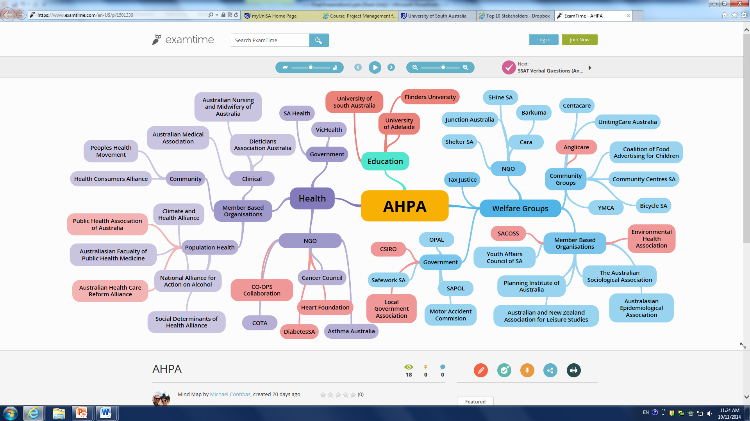

The AHPA executive committee would like to thank the University of SA student project team for their work and professionalism in which they undertook engagement this project.

**Annabel Axford**

**Student Conference Scholarship**

On scholarship; the 2014 Australian Health Promotion Association’s National Conference:

Having a strong passion for health promotion and social justice, it was an amazing opportunity for me to be accepted for a scholarship to go to the Australian Health Promotion Associations national conference ‘Equity @ the Centre’. Over the course of the conference, I got to learn about the great work which is being done in health promotion around Australia and got to meet a range of interesting people. The conference had keynotes from an impressive range of professionals who all gave engaging presentations on their work in health promotion. Dr Shelly Bowen presented on obesity and the need to focus on implementing health promoting systems rather than individual behaviour change in order to improve the health of our population. She also emphasised the need to build systems, not projects, through embedding prevention into our health system in order to tackle continuous funding issues to health promotion; a point I feel is very relevant in today’s political environment. Paul Pholeros also gave a memorable presentation on his work with Healthabitat illustrating through linking environment and health care that health promotion is everywhere in our everyday lives. Although Paul has not come from a health background, his work largely invests in the health and wellbeing of populations through ensuring working household facilities and suitable living environments in underprivileged communities. His take home message, ‘the problem is not the people, the people are the solution’, focused on the importance of empowerment and community engagement. Martin Laverty presented on the economics of social justice and the idea of equity as an asset which governments should invest in. He suggested the need to address the different silos i.e. education, housing, and transportation to look for ways to work within the system, rather than looking for ways to change it. He also brought up the Canadian initiative of health care professionals screening for poverty, an idea I feel should be implemented in our own health care systems here in Australia as poverty is a major determinant of poor health outcomes.

During the conference I was also lucky enough to be a table facilitator in Janette Young’s interactive world café session ‘W(h)ither Health Promotion? AHPA beyond survival to thriving in tough times’ in which interesting discussion took place around the conference themes of legendary leadership, smart systems, power of language and creative solutions. Some key points arising from the conversation included: the need to build partnerships with a range of people outside of our immediate circles whose values align with those of health promotion, the importance of political engagement, and to be flexible with the language which we use to describe health promotion as in tough times it is not in the technical terminology but the broad range of skills that we practice which matters.

There was a strong focus on incorporating and encouraging the use of social media in the conference. I had not used Twitter before the conference however had been aware of its increasingly popular role in health promotion. As the conference were heavily encouraging the use of Twitter during the conference, I decided to sign up and get tweeting. Over the two days I found myself getting involved with the Twittersphere zone and quickly realised its usefulness as a source of information sharing. Twitter during the conference was a useful way to hear the range of opinions and perspectives on what was being discussed at the conference and the conversations which were sparked in response as well as getting a glimpse of the sessions I did not attend. Along with this, there was positive feedback from those who were unable to attend the conference in person but who could still get an idea of what was being discussed from following #equity14.

Overall, I found the most valuable aspect of the conference to be the environment of being around so many other passionate, like-minded people and the energy which was generated from such a group who were all there to support health promotion and share their research and experiences. Attending as a university student in my final year majoring in health promotion, I found this both inspiring and empowering. While there has been a lot going on with funding issues and upset and outrage, it was clear that this energy will be transferred into action and that there are others who are willing to continue to fight for health promotion and live out its core principles in their everyday work.

**Aimee Brownbill**, AHPA SA Conference Scholarship awardee 2014

(Bachelor of Health Sciences, The University of Adelaide)

**Mentoring program review (internal to AHPA SA)**

The mentoring program was endorsed as an initiative in 2000 at the SA AHPA branch AGM and a pilot program developed with the support of some funds from the Department of Human Services, Health Promotion SA. It has run annually since its inception and since 2004 has been jointly run as a partnership with PHAA (Public Health Association Australia) SA. In 2014 the mentoring program was not undertaken by AHPA SA as part of a broader interest in reviewing the activities of the branch. The Vice President and I met with our PHAA counterparts early in 2014 to be respectful of their engagement.

An internal review of the program identified the following information (based on 2013 data and discussion with AHPA members who had been mentors and mentees):

* Size of the program : usual number has been about 25 mentors and mentees
* Balance of AHPA : PHAA participants – c 2:1 PHAA: AHPA mentees; in 2013 only 4 mentors were AHPA members – the cuts to specific Health Promotion positions has impacted here. Even if people are undertaking Health Promotion work many feel very constrained with regard to professional development activity.
* We have partnered with AHPA NT Branch for several years – this had worked well initially but had tapered off with lower mentee applications and mentors reporting lack of contact with mentees.
* Mentee requests have become increasingly specific eg wanting a medically trained person who had experience in population health, epidemiology, community work rather than more generally wishing to know about and connect with the health promotion field.
* There was a sense that the role of mentoring was being seen as more functional (find me a job) rather than exploring a mentees skill sets and considering how this might mesh with the HP field.

 The following questions and areas for exploring have been raised by our committee:

* What were the programs original aims? Are these still relevant? useful? appropriate? Specifically - are they appropriate for AHPA SA now?
* Given the significantly changed environment facing health promotion in recent years should a mentoring focus be both more specific linked to key fields (smoking cessation; specific health issues) and/or less health systems hubbed?
* How do we use the online environment and social media for the progression of networking and career development?
* Does the old model just need some re-focussing? Is annually too often? Should we start with mentors on offer (have been recruiting mentees then finding appropriate mentors).
* What other relationships might need to be developed to facilitate any changes in directions.

There are discussions occurring at the national level with regard to developing a national AHPA mentoring program. This would enable SA members to engage with peers across Australia broadening their understandings and horizon of health promotion.

We welcome members comments, thoughts and ideas on this topic.

**Janette Young, Annabel Axford, Susan Cameron**

**Social Media Working Group**

Mid way through this year the AHPA SA branch began its social media journey by joining Facebook. With the support of social media guru Kristy Schirmer ([www.zockmelon.com.au](http://www.zockmelon.com.au)), a team consisting of Aimee Brownbill, Liana Bellifemini, Kristy Stengert, Alex Jackson and Adam Delaine (with input from the rest of the committee) formulated a social media strategy which has resulted in the following:

* A Facebook page for the public ([www.facebook.com/AHPA.SABranch](http://www.facebook.com/AHPA.SABranch)). The goals of this page are to:
  + Promote AHPA to non-members
  + Raise AHPA’s public profile
  + Advocate for health promotion
* A Facebook group for members (Search ‘[Australian Health Promotion Association – SA Branch Members](https://www.facebook.com/groups/740252506019445/)’). The goals of this page are to:
  + Provide a means for members to communicate with the committee
  + Demonstrate the work AHPA does to the members
  + Promote current opportunities to members such as networking events, scholarships, awards and jobs.

Over 3 months the public page now has 60 followers and the members group has 23 followers. In 2015 we aim to get the majority of AHPA members involved with AHPA on social media.

**Adam Delaine**

**2014 AHPA Student Awards**

In 2003 the Australian Health Promotion Association (SA Branch) established an award for one student from each of the universities in South Australia. The criteria established for these prizes is a combination of academic achievement and demonstration of a commitment to Health Promotion.

Students receive recognition, a certificate, book voucher, and are eligible to be the student representative on Australian Health Promotion Association, (SA Branch) Committee

The very worthy 2014/15 AHPA student prize winners are:

University of Adelaide: Alison Barrett

Flinders University: Alexandra Munt

University of South Australia: Bianca Fisher

**Kristy Stengert**

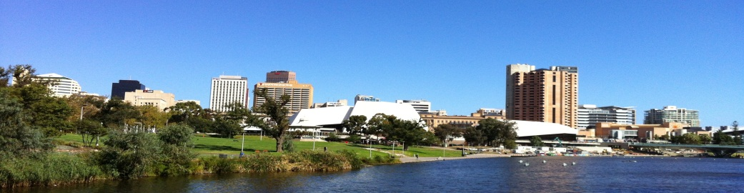



**12th Biennial ANZALS Conference**

***Leisure as a Human Right***

Dear [Recipient Name]:

On behalf of the Australian & NZ Association for Leisure Studies (ANZALS) 2015 Conference Organizing Committee I would like to thank you for your interest to be involved as an in-kind supporter of the conference to be held from the 9th-11th December, 2015 at the University of South Australia, City West campus.

With the support of your organisation we are seeking to develop a productive and collegial conference that brings together both academics and practitioners in the fields of recreation, leisure, sport and the arts as they pertain to health promotion and public health

The ANZALS 2015 Conference Organizing Committee are also looking forward to the development of a working partnership between AHPA (SA Branch) and ANZALS, with the prospects of this partnership becoming more formalized in the near future.

Thank you again, and we look forward to your continued support.

Sincerely,

[Your Name]

Ph: 8302 2505

E: [richard.mcgrath@unisa.edu.au](mailto:richard.mcgrath@unisa.edu.au)



**12th Biennial ANZALS Conference**

10 December - 12 December 2015

Adelaide, South Australia

# Leisure as a Human Right

The right to access and participate in leisure is enshrined in a number of international conventions and declarations. While there has been global consensus that access to leisure is a human right, there still remain a number of challenges and issues that individuals, communities and nations face in relation to fulfilling this right.

The 12th Biennial ANZALS Conference will provide an open and collegial environment where academics, policymakers and practitioners can come together to discuss and debate a variety of global and local leisure issues.

**To receive further information about the call for papers or delegate information, register your interest here:**

<http://www.unisa.edu.au/calendar/12th-biennial-anzals-conference/>

More information about ANZALS is available from [www.anzals.org.au](http://www.anzals.org.au)



